SIMATS ENGINEERING

ASSESSMENT TOOL 1

COURSE NAME: Ethical Hacking COURSE CODE: ITA14

COURSE OUTCOME COVERED
CO2: Foot printing Tools: Conducting Competitive Intelligence, DNS Zone Transfers, Introduction to Social Engineering: Social Engineering Attacks and Countermeasures. (BT3)
Assessment Tool Weightage: 30%

Duration: 90 min Total Marks: 50

Report Analysis

Questions

- A security analyst performed a network scan on the target 192.168.1.10 using the Nmap tool. The report identified several open ports, including HTTP (80), SSH (22), and MySQL (3306), along with the operating system and service versions. Analyze the report and explain the security risks associated with the identified services. Discuss how an attacker could exploit these services and recommend suitable security measures to protect the target system. (20 Marks)
- A phishing awareness campaign was conducted for employees of ABC Technologies Pvt. Ltd. using the GoPhish tool. The report indicates that 40% of employees clicked the phishing link, 20% entered their login credentials, and several users downloaded a malicious attachment. Analyze the report and identify the security weaknesses demonstrated by the employees. Recommend suitable user awareness programs, email security controls, and organizational policies to reduce the risk of successful social engineering attacks.(20 Mark).
- A DNS assessment report generated using the Dig tool shows that the organization's DNS server permits a successful DNS Zone Transfer (AXFR), exposing internal hostnames, mail servers, and DNS records. Analyze the report and explain the security implications of the exposed information. Discuss how attackers could exploit these findings and recommend best practices to secure the DNS infrastructure..(10 Marks)

Code of Conduct:

I B venkatesh (192210495) (Name / Reg No) certify that this submission is my original work and that I have adhered to the guidelines specified for this assessment.
I understand that any violation of academic integrity rules will result in disciplinary action.

Signature of the student:
B Venkatesh

RUBRICS FOR CALCULATION

Report Analysis

Criteria | Weightage (%) | Level 4 (Exemplary) | Level 3 (Proficient) | Level 2 (Developing) | Level 1 (Beginning)
 | 25% | Accurately | Correctly | Identifies only | Unable to
 |  | interprets the | interprets most | some findings | interpret the
 |  | security report, | findings with | and provides | report or
Report Analysis and Interpretation |  | identifies all key findings, and  explains their  significance with | minor  omissions or inaccuracies. | limited interpretation. | identify key findings.
 |  | excellent
 |  | technical
 |  | understanding.
Identification | 25% | Correctly | Identifies most | Identifies only | Fails to identify
of Security |  | identifies all | risks and | a few risks with | major risks or
Risks and |  | security risks, | vulnerabilities | limited | vulnerabilities.
Vulnerabilitie |  | vulnerabilities, | with minor | technical
s |  | and possible | errors. | explanation.
 |  | attack vectors
 |  | with clear
 |  | technical
 |  | justification.
Application | 30% | Applies | Recommends | Provides | Recommendati
of |  | appropriate | suitable | limited or | ons are
Cybersecurit |  | ethical hacking | countermeasure | partially | inappropriate,
y Concepts |  | concepts and | s with minor | appropriate | incomplete, or
and |  | recommends | technical gaps. | recommendatio | missing.
Countermeas |  | comprehensive, |  | ns.
ures |  | practical, and
 |  | technically sound
 |  | countermeasures.
Technical | 20% | Response is well- | Response is | Response lacks | Response is
Communicati |  | organized, | organized and | clarity, | poorly
on and |  | technically | understandable | organization, or | organized,
Documentati |  | accurate, clearly | with minor | contains several | incomplete, and
on |  | presented, and | documentation | technical | difficult to
 |  | uses appropriate | or presentation | inaccuracies. | understand.
 |  | cybersecurity | issues.
 |  | terminology
 |  | throughout.

Questions

- A security analyst performed a network scan on the target 192.168.1.10 using the Nmap tool. The report identified several open ports, including HTTP (80), SSH (22), and MySQL (3306), along with the operating system and service versions. Analyze the report and explain the security risks associated with the identified services. Discuss how an attacker could exploit these services and recommend suitable security measures to protect the target system. (20 Marks)

Commands :
  - nmap scanme.nmap.org
  - nmap -sV scanme.nmap.org
  - sudo nmap -O scanme.nmap.org
  - sudo nmap -A scanme.nmap.org

Observation :

    - The host is alive.
    - HTTP (80) is open.
    - SSH (22) is open.
    - SIP ports 5060 and 5061 are open.
    - Operating system information identified.

Security Recommendations :

    - Keep all software updated.
    - Enable firewall protection.

    - Use strong authentication mechanisms.
    - Perform periodic vulnerability assessments.
    - Conduct regular penetration testing.

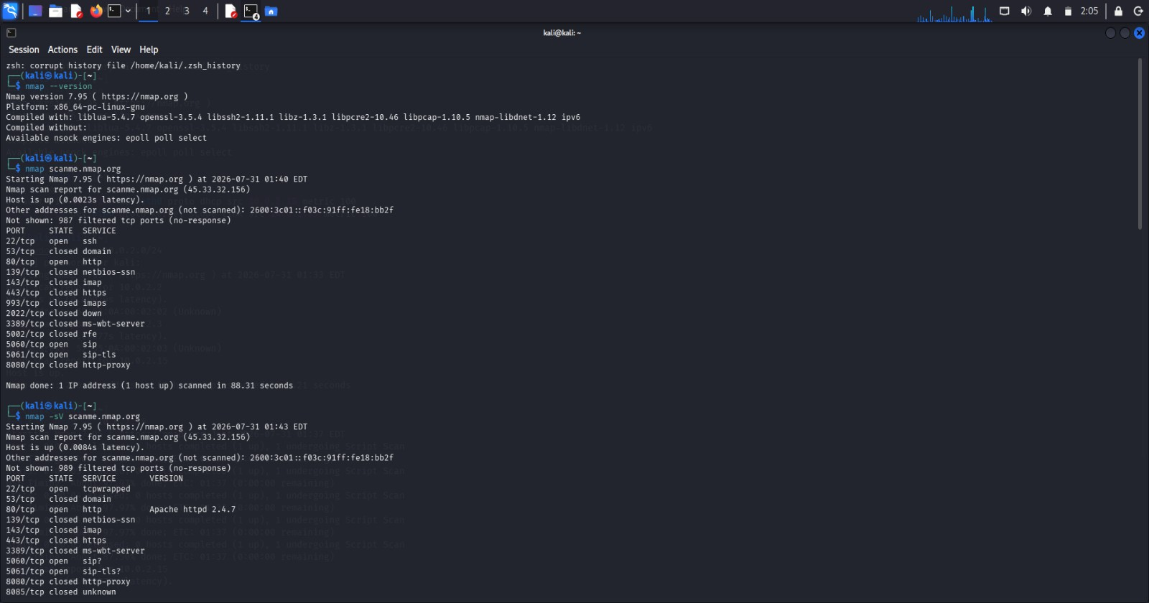
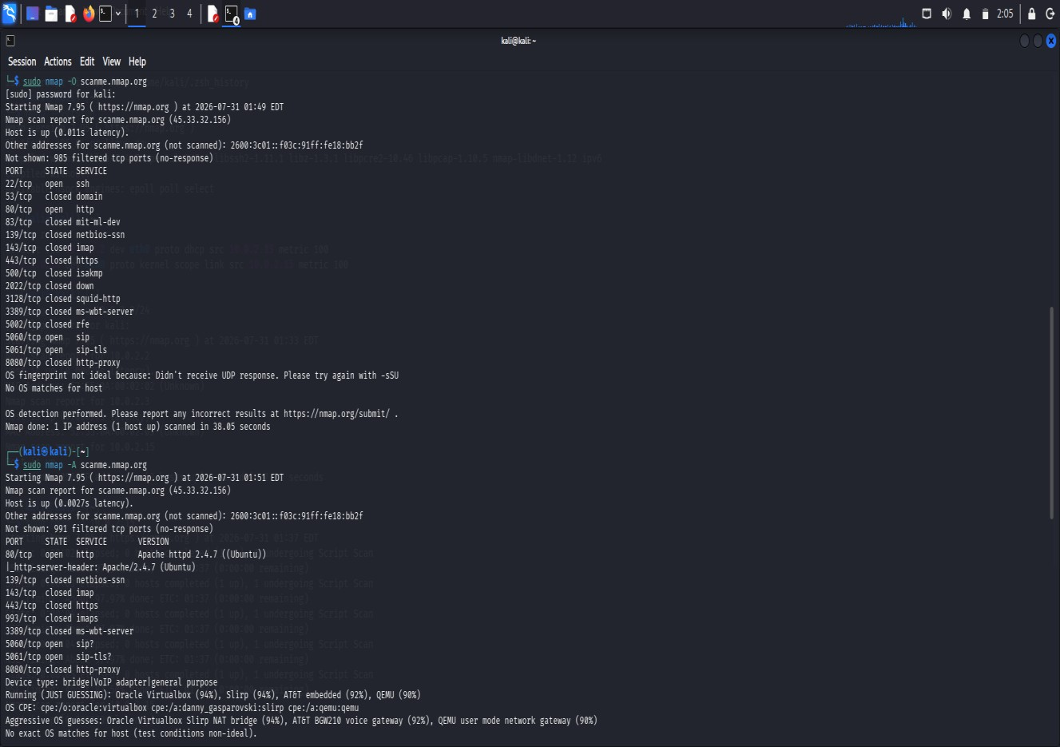

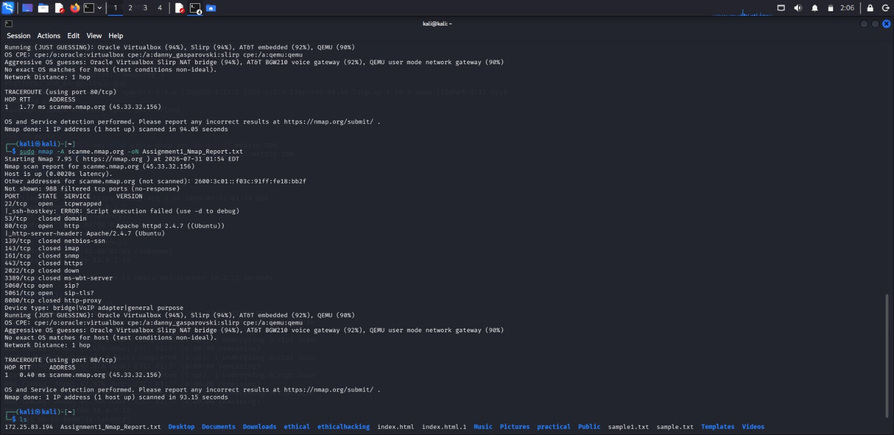

Risks
- Exposure of server information
- Credential theft
- Unauthorized system access

Conclusion
The Nmap Aggressive Scan successfully identified the target's IP address, open ports, running services, and probable operating system details. Such information can be valuable during the reconnaissance phase of an attack and may be used to conduct convincing social engineering attacks against IT support personnel. Implementing strong security controls, regular patch management, and employee awareness training can significantly reduce these risks.

- A phishing awareness campaign was conducted for employees of ABC Technologies Pvt. Ltd. using the GoPhish tool. The report indicates that 40% of employees clicked the phishing link, 20% entered their login credentials, and several users downloaded a malicious attachment. Analyze the report and identify the security weaknesses demonstrated by the employees. Recommend suitable user awareness programs, email security controls, and organizational policies to reduce the risk of successful social engineering attacks.(20 Mark).

Sol : To conduct a phishing awareness simulation using GoPhish by creating an email template, sending phishing emails to dummy employee accounts, monitoring user interactions, and generating a report showing delivery rate, email open rate, and click rate. Finally, recommendations are provided to improve user awareness against phishing attacks.
Command 1 : sudo apt update

Purpose :
Updates the Kali Linux package repository to ensure the latest package information is available before installing software.

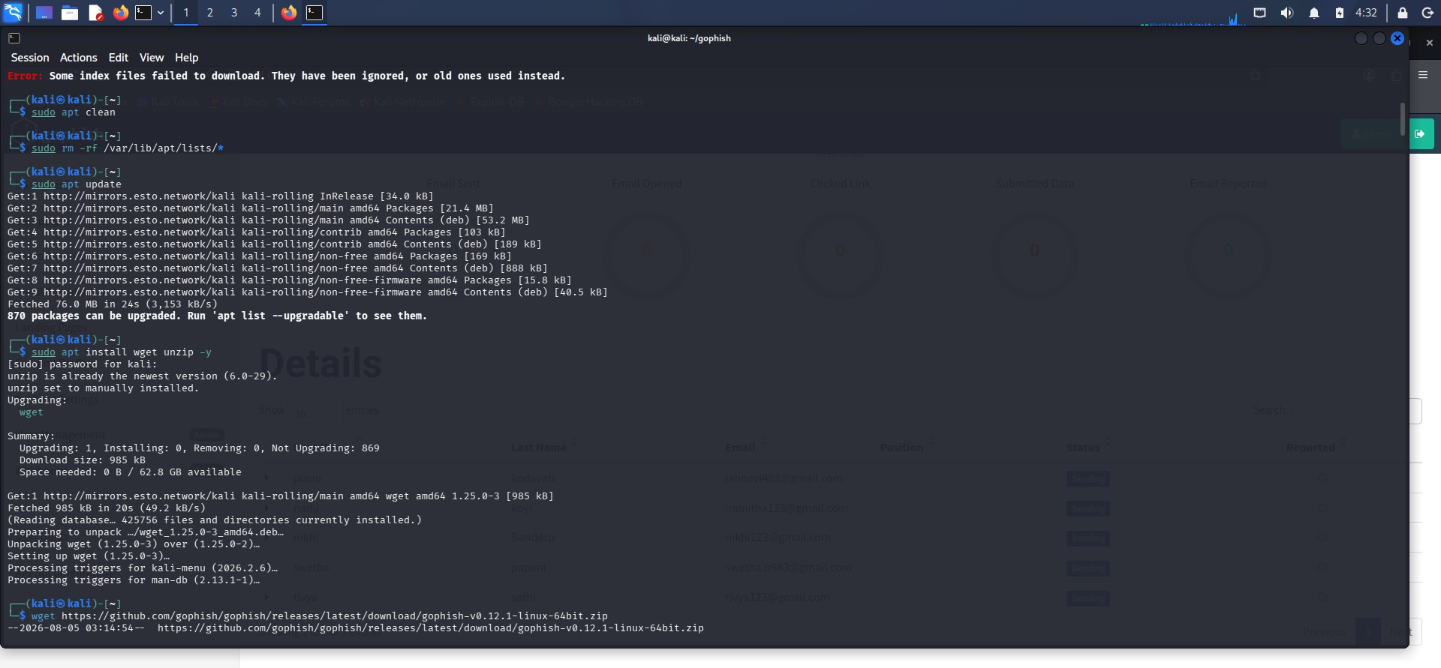
Command 2 : wget https://github.com/gophish/gophish/releases/latest/download/gophish-v0.12.1-linux-64bit.zip

Purpose :
Downloads the latest GoPhish Linux package from the official GitHub repository.

Command 3 : unzip gophish-v0.12.1-linux-64bit.zip -d gophish
Command 4 : cd gophish
Command 5 : chmod +x gophish
Command 5 : sudo ./gophish

Purpose :
Extracts the downloaded GoPhish ZIP archive into the gophish directory. Changes the current working directory to the GoPhish installation folder. Grants execute permission to the GoPhish executable so that it can be started. Starts the GoPhish application, initializes the database, generates SSL certificates if required, and launches the phishing server and the administration web interface.



Report : https://127.0.0.1:3333/
ABC Technologies Phishing Awareness C

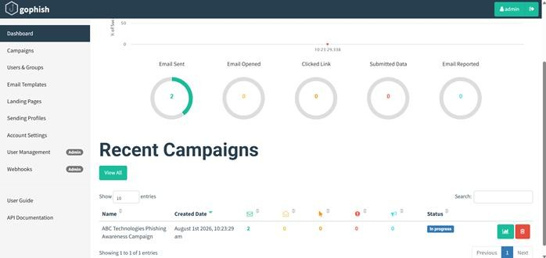

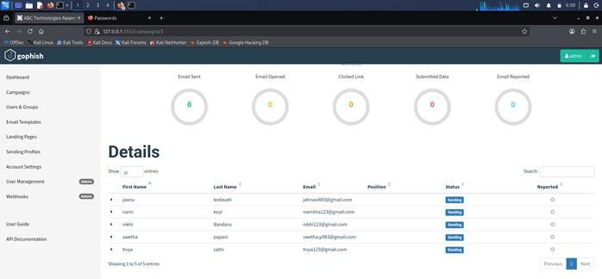

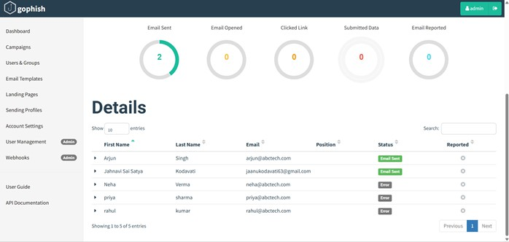

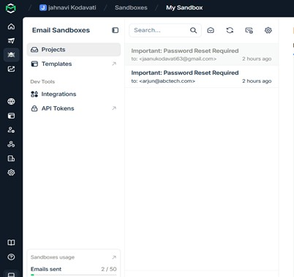

Email Security Controls :

- Enable Spam Filtering.
- Use Email Gateways.
- Configure SPF (Sender Policy Framework).
- Configure DKIM (DomainKeys Identified Mail).
- Configure DMARC (Domain-based Message Authentication, Reporting, and Conformance).
- Block dangerous attachments.
- Scan email attachments using antivirus software.
- Enable URL filtering

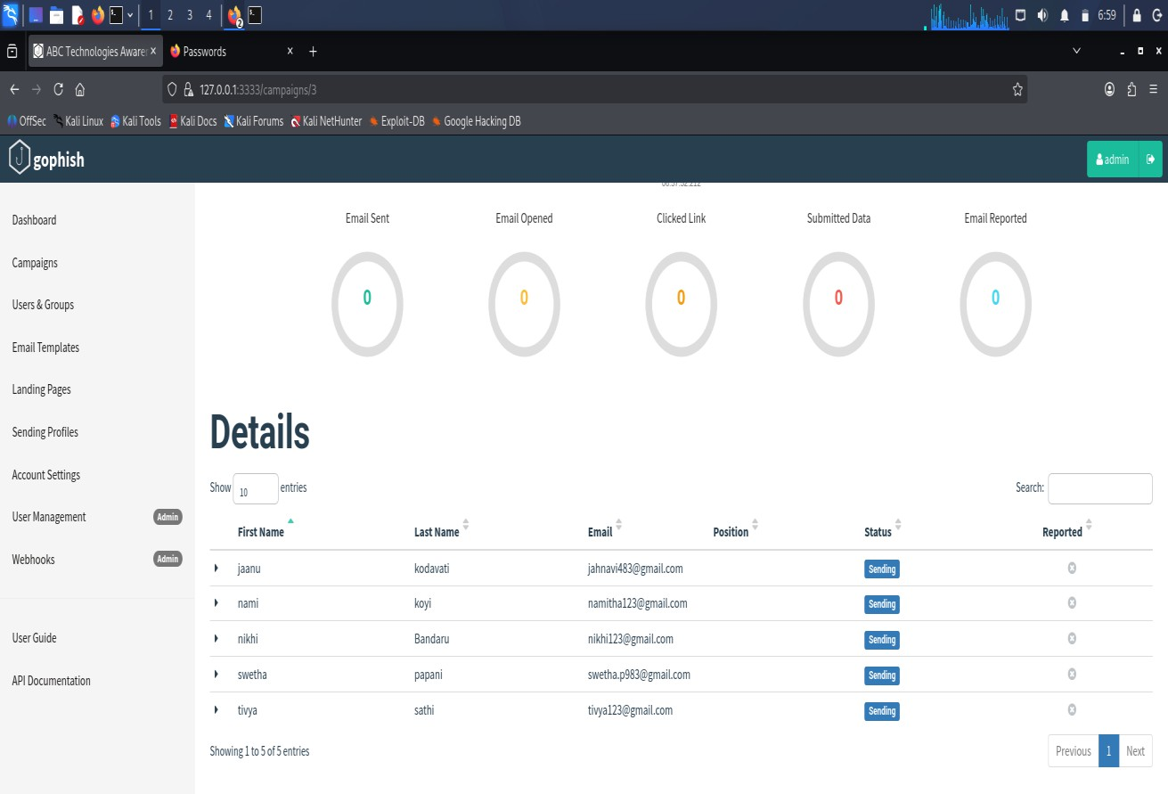

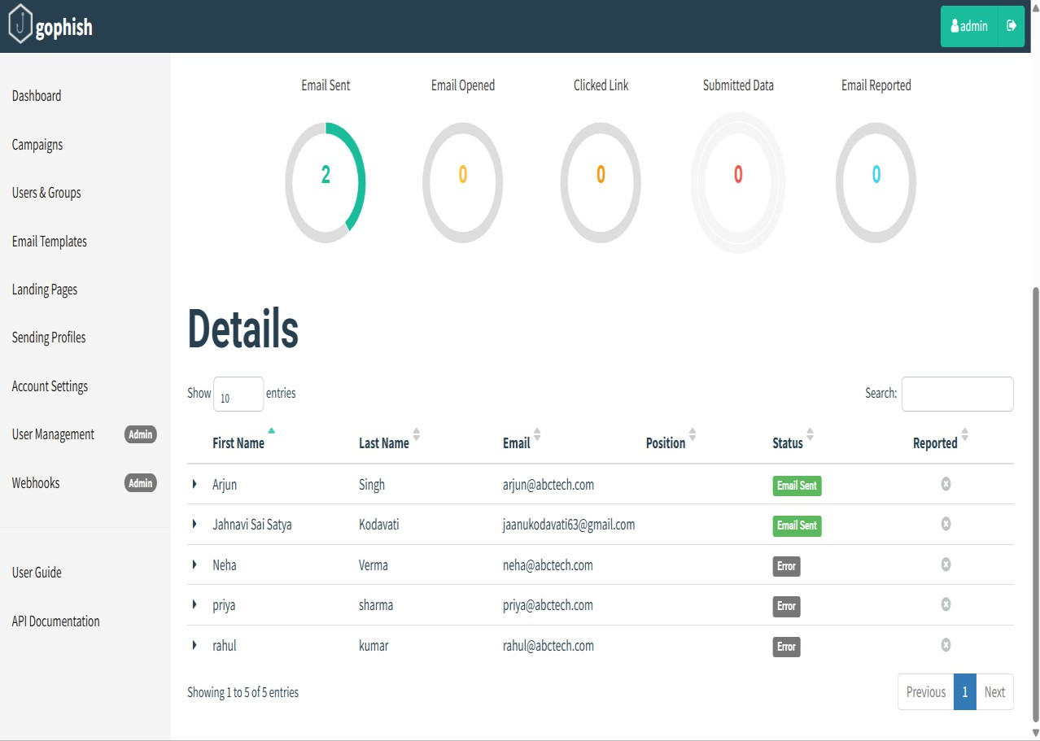
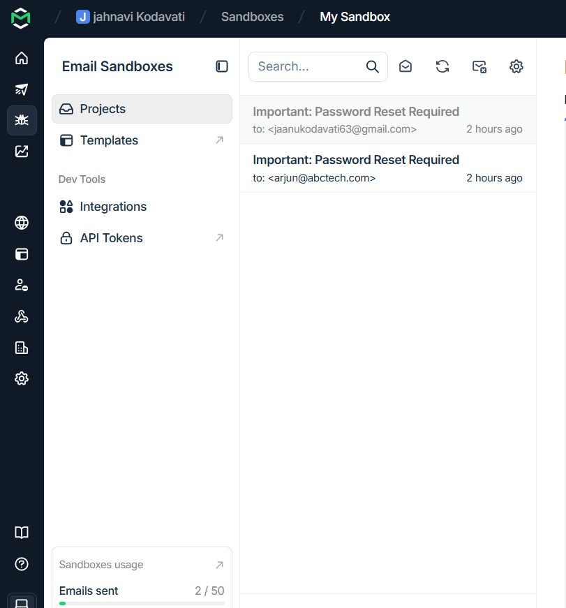

- A DNS assessment report generated using the Dig tool shows that the organization's DNS server permits a successful DNS Zone Transfer (AXFR), exposing internal hostnames, mail servers, and DNS records. Analyze the report and explain the security implications of the exposed information. Discuss how attackers could exploit these findings and recommend best practices to secure the DNS infrastructure..(10 Marks)

Command :
dig AXFR zonetransfer.me @nsztm1.digi.ninja

Observation :

- DNS Zone Transfer succeeded.
- Internal DNS records were exposed.
- Mail server records were visible.
- Multiple hostnames and IP addresses were disclosed.

Possible Attacks :

An attacker can use the exposed information to:

- Perform reconnaissance.
- Scan exposed servers.
- Launch phishing attacks.
- Target mail servers.
- Exploit vulnerable web servers.
- Attempt brute-force attacks on exposed services.
- Prepare for advanced cyberattacks.

To Secure DNS Infrastructure :

- Disable DNS Zone Transfer for unauthorized users.
- Allow AXFR only between trusted DNS servers.
- Configure Access Control Lists (ACLs).
- Enable DNSSEC to protect DNS integrity.
- Regularly update DNS software.
- Monitor DNS logs.
- Remove unnecessary DNS records.
- Perform regular DNS security audits.

